Website Content Final – Jatin

Home – First Page

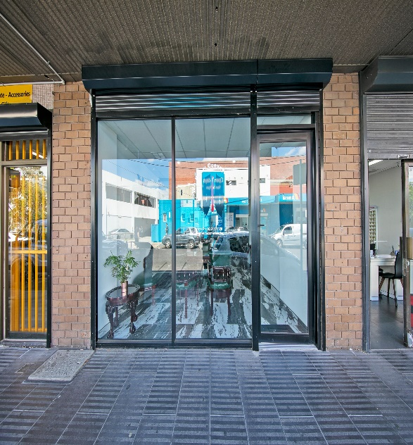

Ro

Rotating Pics 👆



WE KNOW CONVEYANCING is a team of conveyancers who are young, passionate, and vibrant. Unlike traditional conveyancing firms, we prioritize speed, approachability, and reliability. We are always available to answer your calls and respond to emails promptly.

Buying or selling a property is a significant transaction that can be both exciting and stressful. At WE KNOW, we aim to make the entire process stress-free for our clients, from start to finish. We understand that each conveyancing transaction is unique and requires personalized attention. That's why we spend quality time with our clients, regardless of whether they are buying or selling their first home or an investment property.

OLD IS GOLD BUT NEW IS DIAMOND.

Who has a printer or a scanner these days? We offer a paperless experience to our clients, (except in situations where there is no other option). This means that you won't have to worry about printing, scanning, or figuring out where to sign documents throughout the transaction. We use electronic signing platforms to send most of our documentation, which not only saves paper but also saves you time.

With us you don’t go to post office to complete your ID check, it is done electronically doesn’t matter where you are. All you need is yourself, your 100-point ID and a smartphone.

WHERE HAS ALL THE PAPER GONE?

Answer to above question is - In the cloud.

As a paperless office, we do not have massive filing cabinets. Instead, we securely store all your data in the cloud, allowing us to provide documentation promptly to you, your lending specialist, and all other parties involved in the transaction within seconds.

We take pride in providing exceptional customer service. Don't just take our word for it; read our reviews [HERE](https://g.co/kgs/AVCwnP).

Top of Form

Office Video

Services – Second Page



[pic link](https://www.123rf.com/photo_116188510_happy-family-cartoon.html)

Relater party transfer



[pic link](https://www.caloundracityrealty.com.au/2019/06/upgraded-online-property-advertisements-are-a-win-for-the-agent-not-for-the-seller-the-cost-of-advertising-1-3/)

Sale



[Pic Link](https://www.guildproperty.co.uk/news/post-8-rules-for-buying-property-1552907076)

Purchase



Business Conveyancing

Use similar picture or download from

https://wkconveyancing.sharepoint.com/:i:/s/allcompany/EamltMx_WQVMorrcpjYF0tUB-pXzLDDvh1vwzMlYqUkc-w?e=9guHTF

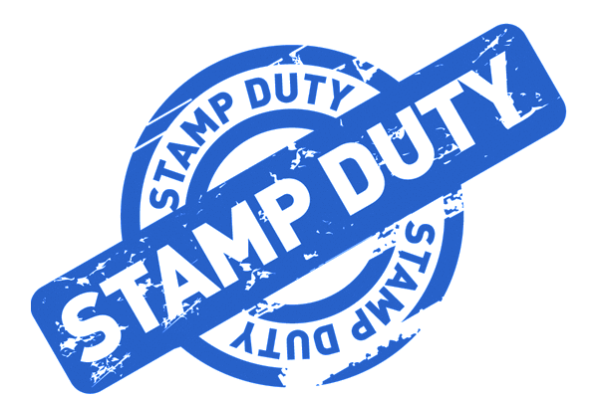

[pic link](https://stampduty.calculatorsaustralia.com.au/sites/default/files/stamp-duty.png)

Stamp duty refund



[pic link](https://blog.hashching.com.au/wp-content/uploads/2016/06/AdobeStock_65187309.jpeg)

First home owners grant

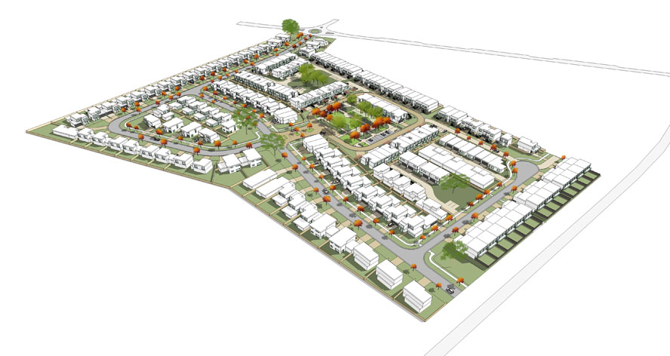[pic link](https://amcarchitecture.com.au/wp-content/uploads/2016/12/Portfolio-Residential-Watson-Subdivision-Aerial-2.jpg)

Subdivisions

Content for above pages:

Sale

Now that you have decided to sell your property, Vendors has to provide the copy of contract of sale and section 32 to the prospective purchasers.

What is Contract of Sale and Section 32?

Contract of Sale of property is a legal agreement between a seller and a buyer for the sale of real estate. This type of contract typically includes a detailed description of the property being sold, including its location, boundaries, and any buildings or other improvements on the land.

Section 32 In Victoria, Australia, Section 32 (or Section 32 Vendor's Statement) refers to a legal document that a seller of residential or commercial property is required to provide to a prospective buyer before the sale is finalized.

Who prepares Contract of Sale and Section 32?

We Know Conveyancing will prepare the Contract of sale and Section 32, we will ensure that the documents are accurate, complete, and comply with all legal requirements.

What Do I need to do to obtain Contract of Sale and Section 32?

You need to provide us with some information and documents relevant to your sale. Click on the link below to provide the instructions and upload the relevant options. We recommend you collect the relevant documentation before you start the form from the list below.

Click Here to start the form.

Documents required:

* Lease Agreement – If the house is currently tenanted, please upload the copy of current rental agreement.
* If the building/house is less than 7 years old - Building Permit, Occupancy Permit and Builders Warranty Insurance
* If selling off the plan (House Under Construction) - Building Permit, Builders Warranty Insurance, Inclusion List (If off the plan sale) and Drawings (if off the plan sale)
* If any building works been completed on the property in the previous 7 years, This includes extensions, renovations, garages, pergolas, verandas, decking etc. We will require copies of any Building Permits and relevant Insurance.
* Owners Corporation – If the property is affected by Owners Corporation, please upload the copy of a recent invoice/bill from the Owners Corporation.
* If any Notice has been served recently effecting the land (e.g fencing notice, road widening, road works), please upload copy of notice.

Purchase

Congratulations, you are set on a journey to achieve your property goals. Whether you are a First Home Buyer or an Investor. We can assist you with your dream project.

We can assist you with:

* Purchase of your first home or an investment property whether it is a home, unit or an apartment.
* Purchase of farmland.
* Purchase of commercial properties such as shop, office space, warehouse, Clinics and Medical Centres etc.
* Purchase of residential or commercial property via Self Managed Super Fund.
* Purchase of an untitled Land.

What Do I need to do to start the process?

First Step is to let us review the contract of sale before you sign it, this is crucial DO NOT SKIP this step even if you are a regular investor. Contract review not only protects you but also gives you confidence that you are not signing off your life.

We provide this service free of charge so there is nothing to lose.

Click Here to start the form

Form for Contract Review:

Name

Mobile

Email

Message

Upload your contract

Secondly, at the time of signing the contract of sale provide our contact details (refer to contact page) to Real Estate Agent and ensure they are noted on the contract in Purchaser Representative Section in Particulars of Sale and request that the signed copy of contract of sale and section 32 to be sent to our office instantly. Don’t forget this copy of contract will be supplied to all relevant parties such as your bank. If our details are noted on the contract, it is easy for your bank to contact us for settlement.

Lastly, until we have the information related to yourselves and the property, we are unable to assist you. This step is very important and relatively easy. All you have to do is Click on the link below and fill our online form.

Click Here to start the form

Disclaimer – Please note that until we receive your instructions/form in this matter, we are unable to act on your behalf and hence our office cannot be held liable in any way. Once instructions are received, we need 1 clear business day to prepare the matter and start acting on your behalf.

Related Party Transfers

What is a related Party Transfer?

A transfer of property or a partial share of property to a related party is known as a related party transfer. Related parties may include individuals in personal or business relationships, spouses, or family members.

Some instances of related party transfers may comprise of:

* Transfers between spouses where one spouse is added on title.
* Refinancing where a change of ownership between related parties is required to obtain finance.
* Property settlement due to a divorce or de facto separation.
* Transfers between family members as a gift or below market value.
* Deceased estates where a property is transferred to a beneficiary.

Is stamp duty charged on related party transfers?

Generally, stamp duty is NOT payable on the transfer of shares between husband and wife on their principle of residence and transfer of shares between husband and wife due to separation. Apart of that Stamp Duty is attracted on almost all other type of transfers.

What Do I need to do to start the process?

Give us the instructions by clicking below to complete our online instructions form, we also recommend that you contact before completing the form.

Click Here to start the form

Stamp Duty Refund

If you are eligible for a stamp duty concession, usually it is applied prior to settlement but if for whatever reason, the stamp duty was paid in full at the time of settlement and you believe that you are entitled to a refund, we can certainly assist to lodge the refund application. Please note that it can take anytime between 60-90 days for the application to be processed by State Revenue office Victoria.

What Do I need to do to start the process?

Click Here to start the form

Form:

Address of the Property:

Your Full Name

DOB

Mobile

Email

Current Residential address

Date of settlement

Nationality

If not Australian, are you a permanent resident of Australia.

Is your principal place of residence?

Are you a first home buyer?

Upload the copy of your recent council or water bill?

Upload your Passport or Drivers License

Provide Your Account Details for refund:

Account Name:

BSB:

Account Number:

First Home Buyer Grant

First home buyer grant application is usually lodged by your banker/broker prior to settlement. If for whatever reason it was not lodged, we can certainly assist to lodge the refund application. Please note that it can take anytime between 60-90 days for the application to be processed by State Revenue office Victoria.

What Do I need to do to start the process?

Click Here to start the form

Form:

Address of the Property:

Your Full Name

DOB

Mobile

Email

Current Residential address

Date of settlement

Nationality

If not Australian, are you a permanent resident of Australia.

Is your principal place of residence?

Are you a first home buyer?

Upload the copy of your recent council or water bill?

Upload your Passport or Drivers License

Provide Your Account Details for refund:

Account Name:

BSB:

Account Number:

FIRB Application

Who needs FIRB approval?

Investors who are temporary residents or foreigners are required to obtain approval from the Foreign Investment Review Board (FIRB) before investing in or purchasing residential land in Australia, and there are consequences for those who do not comply.

If a buyer of residential land in Victoria falls into any of the following categories, they may be considered a foreign acquirer for the purpose of obtaining approval from FIRB.

* A person who is not a permanent resident of Australia or an Australian citizen
* A corporation where one or more of the following holds a substantial interest in the corporation:
* An individual not ordinarily resident in Australia
* A foreign corporation; or
* A foreign government.
* A trust where a trustee of the trust is a foreign entity.

If you meet the following criteria, you may be exempt from requiring approval from the Foreign Investment Review Board (FIRB):

* An Australian citizen
* A New Zealand citizen
* An Australian permanent resident; or
* A foreign person acquiring property as joint tenants with their Australian citizen spouse, New Zealand citizen spouse or Australian permanent resident spouse.

Who applies for FIRB?

We do not process applications for FIRB approval, and the majority of our clients complete this process independently through the following online link:

<https://firb.gov.au/apply-now>

If you require any assistance while completing your FIRB application, please do not hesitate to contact our office. We will do our best to provide you with the necessary support.

Subdivisions and consolidation

If you have the plans, we have the way to assist you whether you are planning to Subdivide or Consolidate your land.

Subdivision of Land: Subdivision is the process of dividing a larger parcel of land into smaller, individual lots or parcels. This can involve creating new boundaries, roads, and utilities to facilitate the development of the land for residential, commercial, or industrial purposes. Subdivision is typically subject to local planning and zoning regulations, and may require approval from relevant government agencies or local authorities.

Process - There are usually 3 phases involved when subdividing a block of land:

1. Engage a Surveyor - Once you've decided to subdivide your land, the next crucial step is to engage a qualified surveyor. The surveyor is responsible for obtaining a subdivision permit and preparing the proposed plans in compliance with local regulations. They will guide you through the council application process and obtain necessary approvals from the council and other relevant referral authorities. If you're working with a town planner, they often have trusted surveyors they can refer you to, simplifying the process.
2. Obtaining Authority Approval and Council Certification - Once you engage a surveyor and prepare the proposed plans, the next step is to obtain approval from the council and other relevant authorities for the subdivision to proceed. Apart from the council, other authorities, such as VicRoads, water authority, gas, electricity, and phone bodies, may also have a say in the process. These authorities may impose conditions on the subdivision application that need to be fulfilled before a certificate of compliance is granted, allowing you to create new titles for the subdivided lots. It's important to carefully follow the requirements and conditions set by these authorities to ensure a successful subdivision process.
3. Register Subdivision at Title Office - After obtaining the necessary approvals from the council and relevant authorities, the final step in the subdivision process is to engage We Know Conveyancing to register the plan of subdivision at the title office, resulting in the creation of new titles. Our team plays a crucial role in this step to bring the process to completion.Our responsibilities include drafting the appropriate title office paperwork required for creating the new titles and owners corporations, if applicable, especially in case of shared property. If there is an existing mortgage on your title, we will also seek permission from your bank to register the subdivisions and make the parent title available to us for further subdivision. Our experienced conveyancers will handle the necessary paperwork and coordination with relevant parties to ensure the smooth registration of the subdivision, as per the approved plan.

Partition Agreement: A partition agreement is a legal document that outlines the division of subdivided property among co-owners. When prepared correctly, it can help avoid or minimize the amount of stamp duty payable on the transfer of the property.

A partition agreement is typically entered into after the settlement or subdivision of a property is complete, with the aim of avoiding or minimizing the amount of stamp duty payable on the transfer.

We Know Conveyancing has the expertise to prepare a partition agreement for you and help saving the stamp duty.

Consolidation of Land: Consolidation is the process of merging two or more adjacent parcels of land into a single, larger parcel. This can involve redrawing boundaries, merging titles, and updating legal descriptions to create a unified and larger parcel of land. Consolidation is often done to simplify ownership, resolve boundary disputes, or combine smaller parcels into a larger tract for more efficient land management or development.

What Do I need to do to start the process?

Click Here to start the form

Form:

1. Address of the Property:
2. Your Full Name
3. Mobile
4. Email
5. Message:

Title Insurance: Copy from our current website, Just add

Get a Quote - <https://www.firsttitle.com.au/getquote/>

Last Page Contact US

Same like our current website page.